

Department of Electronics and Computers
Study programme: Applied Electronics

Verification Project
Arithmetic Logic Unit

Table Of Contents

1 Digital circuit Project 3
1.1 Block Diagram 3
1.2 General Description of the DUT Functionality 3
1.3 DUT Interfaces 4
1.4 List of DUT Functionalities 6
1.5 Principle Schematic 7
1.6 Waveforms 8
1.7 Register Table 9
2 Verification of the Digital Circuit Project 14
2.1 Verification Environment Arhitecture 14
2.1.1 Coverage for the “IRQ” Interface 15
2.1.2 APB Driver 15
2.1.3 Monitor for the APB Interface 15
2.1.4 Monitor for the “IRQ” Interface 15
2.1.5 Monitor for the ”result” interface 15
2.1.6 Transaction for the “IRQ” Interface 16
2.1.7 Transaction for the “result” Interface 16
2.2 List of Elements to Verify 16
2.3 Functional Coverage Elements 17
2.4 Tests 19
2.5 Obtained Results 19

Digital circuit Project
Block Diagram
General Description of the DUT Functionality
DUT Interfaces
List of DUT Functionalities
Schematic Diagram
Waveforms
Register Table

Block Diagram
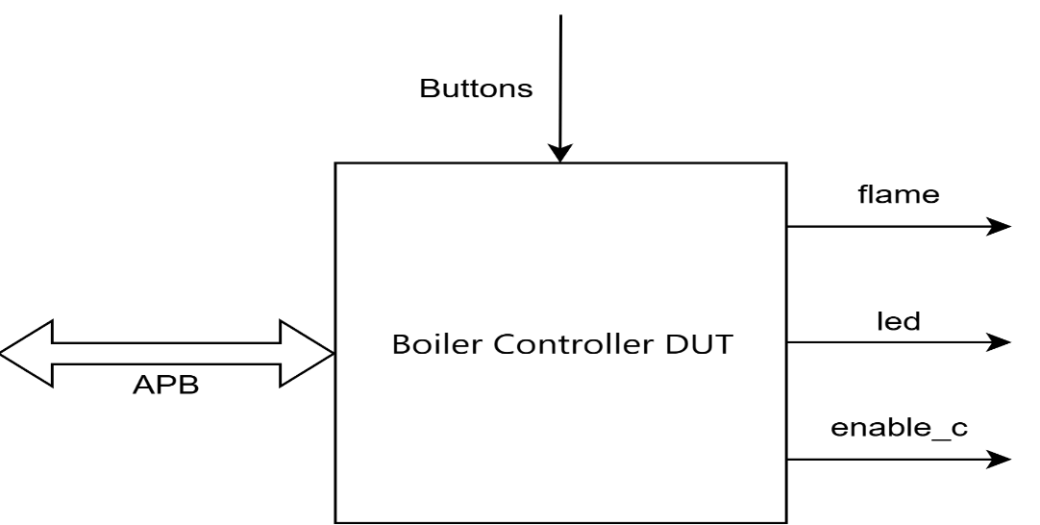
Figure 1. Block Diagram of the Design

General Description of the DUT Functionality
- Using a postfix expression evaluation algorithm, it performs basic arithmetic operations: addition, subtraction, multiplication, division, modulo, right shift, and left shift.
- The final result will be validated on the output interface by asserting the Valid signal.
- Certain situations (failed/completed transaction, FIFO empty/full, bit overflow of the result) will trigger an interrupt request.

Example:
- We will evaluate the infix expression 5 + ((1 + 2) * 4) - 3, which can be written in postfix notation as 5 1 2 + 4 * + 3 -.
- Below is the sequence of steps through which the expression is evaluated according to the postfix evaluation algorithm.
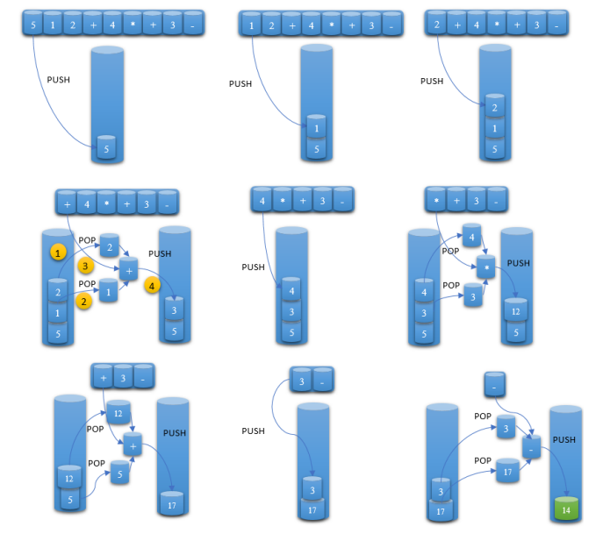
Figure 2. Evaluation of the expression 5 1 2 + 4 * + 3 -

DUT Interfaces

System Interface
Port Name | Size | Direction | Description
clk | 1 | input | System clock; used on the APB interface
rst_n | 1 | input | System reset; active low

APB Interface
Port Name | Size | Direction | Description
psel | 1 | input | Select; indicates the start of the first transfer phase
penable | 1 | input | Enable; indicates the start of the second transfer phase
paddr | 5 | input | Address
pwrite | 1 | input | Write/read enable
pwdata | 32 | input | Write data
pready | 1 | output | Ready; indicates that the slave has completed the transfer
prdata | 32 | output | Read data
pslverr | 1 | output | Slave error; asserted along with pready if the slave encounters an error during transfer

Output Interface
Port Name | Size | Direction | Description
result | 16 | output | Operation result
valid | 1 | output | Validation signal

Interrupt Interface
Port Name | Size | Direction | Description
irq | 1 | output | Interrupt request

List of DUT Functionalities
Functionality List:

- Performs basic arithmetic operations (addition, subtraction, multiplication, division, modulo, right shift, left shift);
- Provides an interrupt request feature;
- The interrupt request can be masked using the IRQ_MASK register;
- A configuration register allows the system to ignore one or more operations;
- A CLOCK_DIVIDER can be used to extend the duration of arithmetic operations;
- A control register allows clearing the interrupt register or the FIFO buffer storing data and operation types;
- If more than one bit is set in the OPERATIONS register in a single APB write, the pslverr signal is asserted;
- Invalid APB address access asserts the pslverr signal;
- To distinguish between data and operations in the FIFO buffer, an additional bit is added (0 for data, 1 for operations).

Principle Schematic
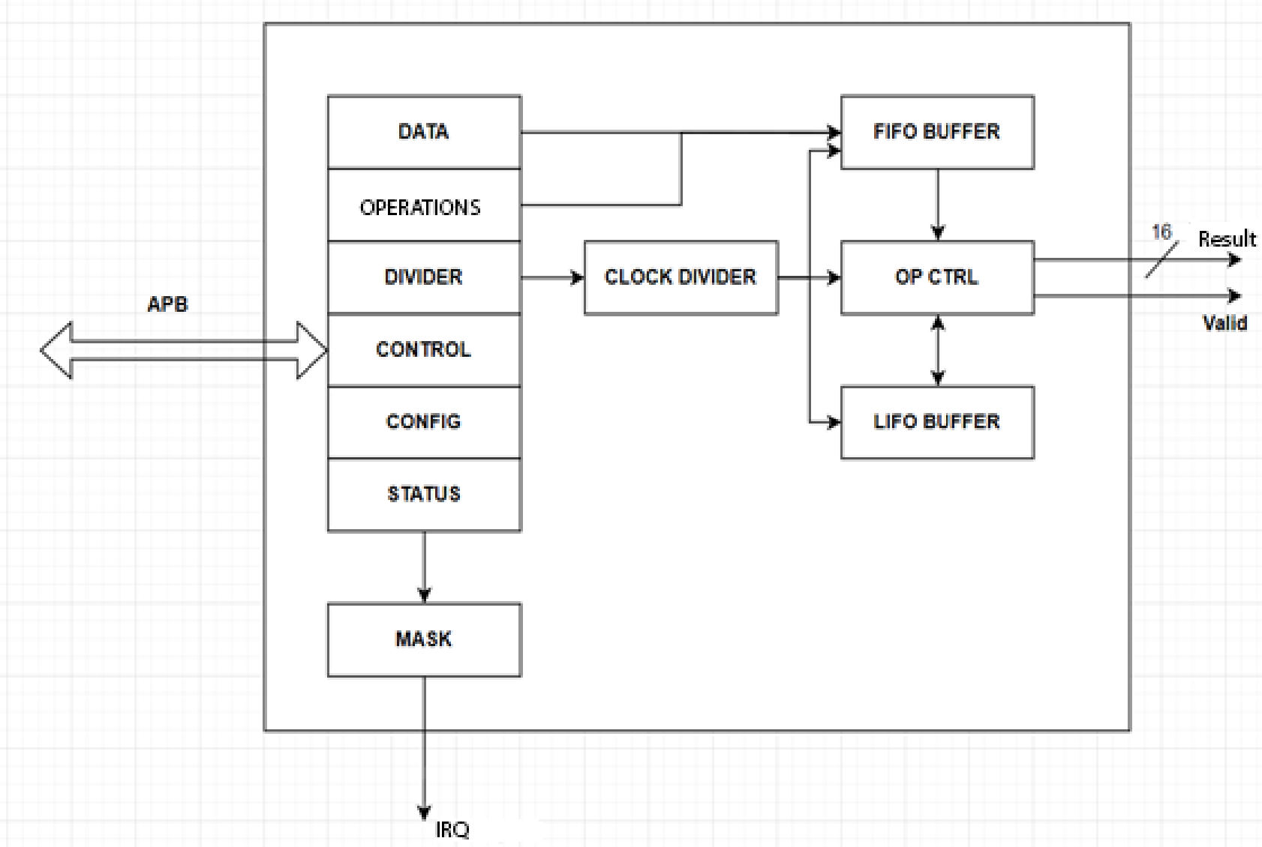

Figure 3. DUT Block Diagram
DUT Limitations:
- The FIFO Buffer can hold only 256 elements, meaning 128 data values and 127 operations.
- The number of data entries must always be equal to the number of operations + 1 for proper functionality.
- Before inserting data into the FIFO buffer, the CLOCK_DIVIDER must be set, and CLEAR_FIFO must be enabled in the CONTROL register;
- To ensure correct operation, only one bit should be written per transaction in the OPERATIONS register; otherwise, the DUT will signal an error on the APB interface by asserting pslverr;
- Data and operations must be entered in a specific order to ensure that, when extracted from the FIFO buffer and placed into the LIFO buffer, at least two data elements are always present in the LIFO.

Waveforms

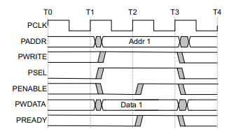
Figure 4. APB Write Transfer
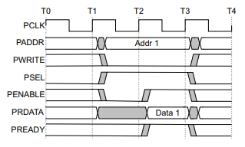
Figure 5. APB Read Transfer
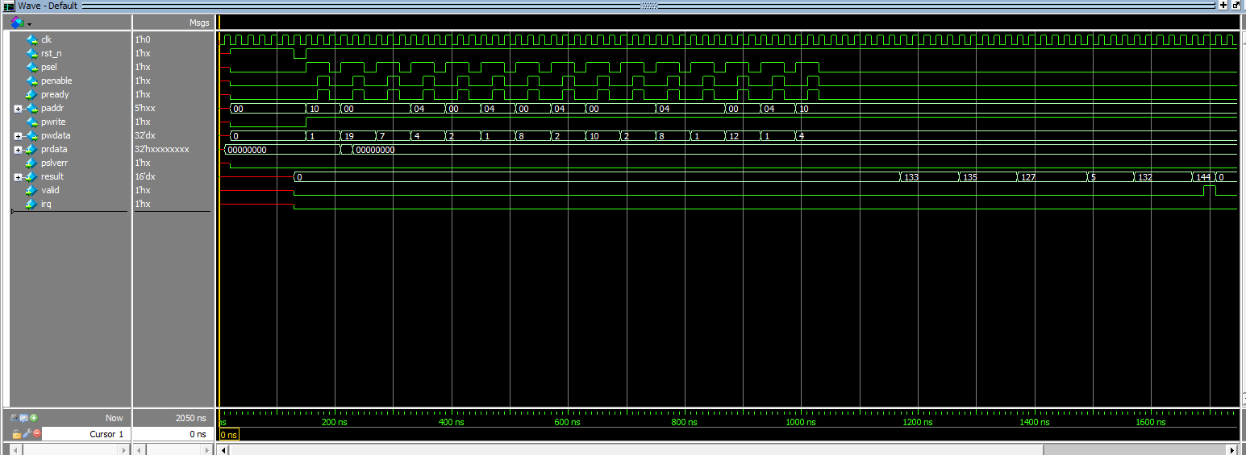
Figure 6. DUT Operational Waveforms

Register Table

Registers Map:
Name | Address | Type | Reset value | Description
DATA | 0x00 | WO | 8’b0 | Register for input data
OPERATIONS | 0x04 | WO | 8’b0 | Register for input operations
STATUS | 0x08 | RO | 8’b0 | Transaction status register
DIVIDER | 0x0C | RW | 8’bFF | Clock divider register
CONTROL | 0x10 | RW | 8’b0 | Control register
MASK | 0x14 | RW | 8’b0 | Interrupt request mask register
CONFIG | 0x18 | RW | 8’b0 | Configuration register

DATA register
FIELD | NAME | TYPE | RESET VALUE | DESCRIPTION
7:0 | Value | WO | 8’b0 | Data for the operation

OPERATIONS Register
FIELD | NAME | TYPE | RESET VALUE | DESCRIPTION
7 | Reserved
6 | Shift Right | WO | 1’b0 | -
5 | Shift Left | WO | 1’b0 | -
4 | Modulo | WO | 1’b0 | -
3 | Division | WO | 1’b0 | -
2 | Multiplication | WO | 1’b0 | -
1 | Subtraction | WO | 1’b0 | -
0 | Addition | WO | 1’b0 | -

Status register
FIELD | NAME | TYPE | RESET VALUE | DESCRIPTION
7:6 | Reserved
5 | BSY | RO | 1’b0 | 0: DUT is idle, no operation in progress  1: An operation is being executed
4 | Overflow | RO | 1’b0 | Indicates if the result exceeds the maximum bit width
3 | Empty | RO | 1’b0 | Indicates if the FIFO buffer is empty
2 | Full | RO | 1’b0 | Indicates if the FIFO buffer is full
1 | Fail | RO | 1’b0 | Indicates if the operation failed
0 | Done | RO | 1’b0 | Indicates successful execution of an operation

Divider register
FIELD | NAME | TYPE | RESET VALUE | DESCRIPTION
7:0 | CLOCK_DIV | RW | 8’hFF | Clock divider value
Control register
FIELD | NAME | TYPE | RESET VALUE | DESCRIPTION
7:4 | Reserved
3 | Stop | RW | 1’b0 | Forces operation stop
2 | Start | RW | 1’b0 | Initiates operation start
1 | CLEAR_IRQ | RW | 1’b0 | Resets interrupt-triggering fields in the STATUS register
0 | CLEAR_FIFO | RW | 1’b0 | Clears the FIFO buffer

MASK register
FIELD | NAME | TYPE | RESET VALUE | DESCRIPTION
7:5 | Reserved
4 | OVERFLOW_MASK | RW | 1’b0 | -
3 | EMPTY_MASK | RW | 1’b0 | -
2 | FULL_MASK | RW | 1’b0 | -
1 | FAIL_MASK | RW | 1’b0 | -
0 | DONE_MASK | RW | 1’b0 | -
CONFIG register
FIELD | NAME | TYPE | RESET VALUE | DESCRIPTION
7 | Reserved
6 | IGNORE_SHIFT_RIGHT | RW | 1’b0 | If set, the shift right operation is refused
5 | IGNORE_SHIFT_LEFT | RW | 1’b0 | If set, the shift left operation is refused
4 | IGNORE_MOD | RW | 1’b0 | If set, the modulo operation is refused
3 | IGNORE_DIV | RW | 1’b0 | If set, the division operation is refused
2 | IGNORE_MUL | RW | 1’b0 | If set, the multiplication operation is refused
1 | IGNORE_SUB | RW | 1’b0 | If set, the subtraction operation is refused
0 | IGNORE_ADD | RW | 1’b0 | If set, the addition operation is refused

Verification of the Digital Circuit Project
Verification Environment Architecture
List of elements to verify
Functional coverage elements
Tests
Obtained results

Verification Environment Arhitecture

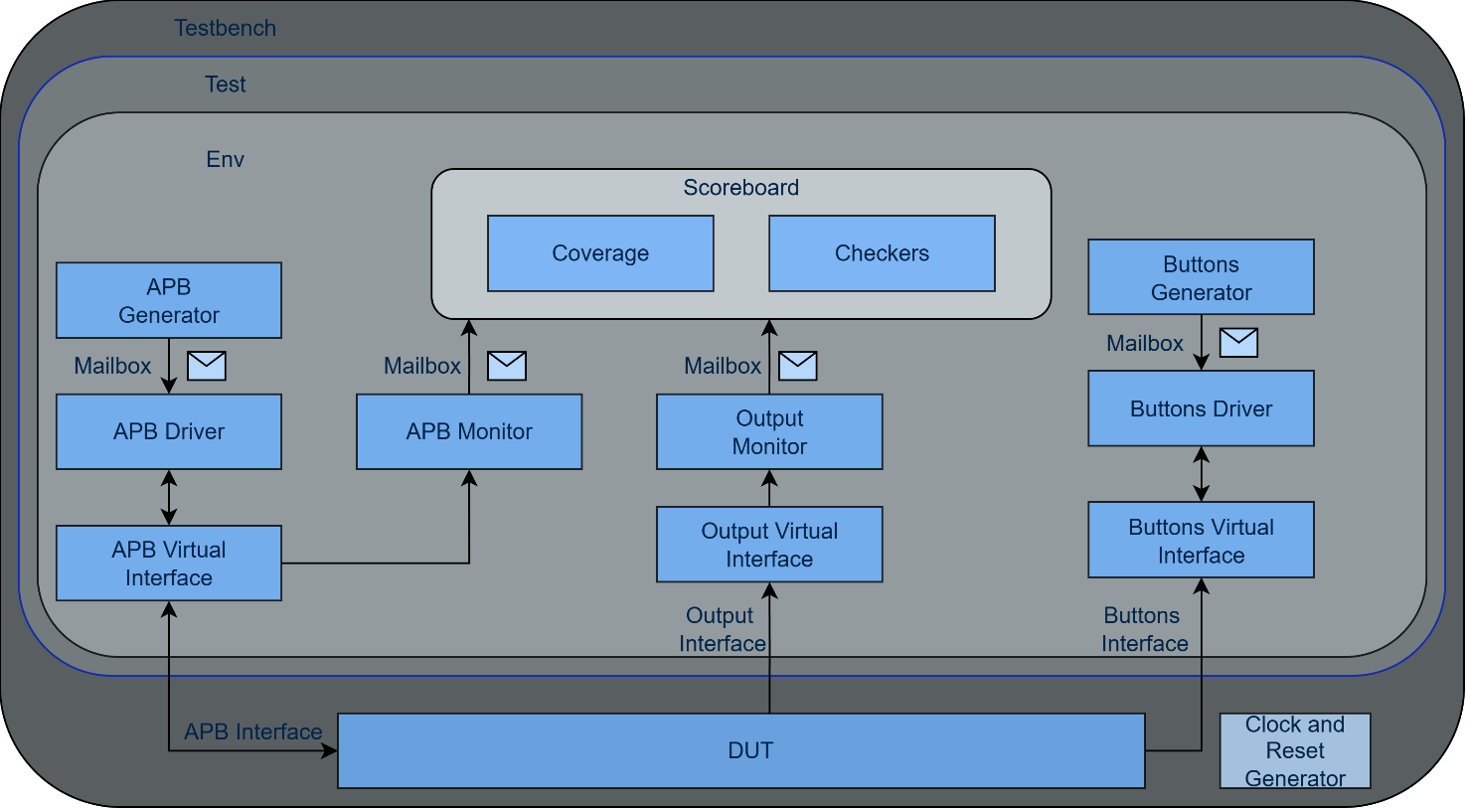

Figure 7. Overview of the verification environment

Coverage for the “IRQ” Interface
IRQ signal values are recorded. If the interrupt was only deactivated, the coverage value is 50%. If, during a test, the interrupt was both activated and deactivated, the coverage value will be 100%.

APB Driver
The driver takes transactions generated at the abstract level by the APB generator and sends them to the APB interface at the signal level.

Monitor for the APB Interface
Monitors the signals on the APB interface and sends transactions to the scoreboard.

Monitor for the “IRQ” Interface
This monitor implementation captures transactions (tracks signal activity) from the IRQ interface, creates corresponding transactions, sends them to the scoreboard for verification, and calls the functional coverage collector instance.

Monitor for the ”result” interface
The monitor tracks traffic on the interface where the DUT places the results, retrieves data, and reconstructs transactions (in this case, as instances of the result_transaction class). The retrieved data is sent to the scoreboard for verification. The transaction is only captured when the validation signal is 1.
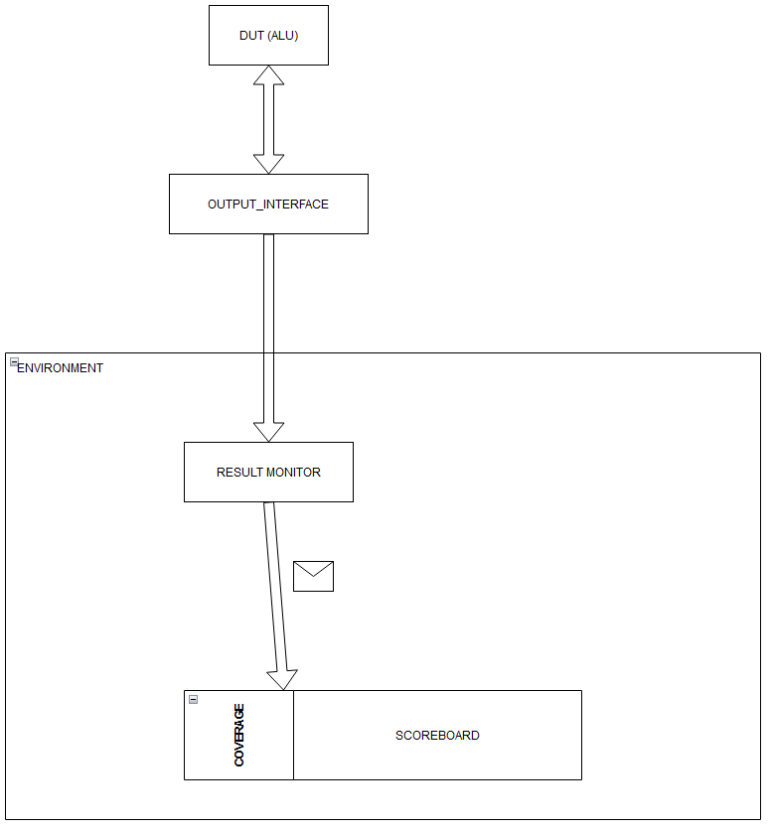
Figure 8. Logical diagram for "result"

Transaction for the “IRQ” Interface
This class represents an interrupt transaction, with a single irq attribute that indicates the state of the interrupt signal associated with the transaction. It also provides functions to display randomly generated values and create copies of transaction objects.

Transaction for the “result” Interface
This class contains a single 16-bit element that sequentially stores the results of operations performed in the DUT.

List of Elements to Verify

Assertion | Description
penable_signal_chk | The penable signal must have a concrete value during a transaction (i.e., when the psel signal is 1).
pwrite_signal_chk | The pwrite signal must have a concrete value during a transaction (i.e., when the psel signal is 1).
paddr_signal_chk | The paddr signal must have a concrete value during a transaction (i.e., when the psel signal is 1).
pready_signal_chk | The pready signal must have a concrete value during a transaction (i.e., when the psel signal is 1).
pslverr_signal_chk | The pslverr signal must have a concrete value during a transaction (i.e., when the psel signal is 1).
pwdata_signal_chk | The pwdata signal must have a concrete value during a transaction (i.e., when the psel signal is 1).
concurrent_pready_psel_chk | The pready signal must not assert simultaneously with psel.
concurrent_penable_psel_chk | The penable signal must not assert simultaneously with psel.
paddr_stable_chk | The paddr signal must remain stable (maintain its value) during a transaction (i.e., when the psel signal is 1).
pwrite_stable_chk | The pwrite signal must remain stable (maintain its value) during a transaction (i.e., when the psel signal is 1).
pwdata_stable_chk | The pwdata signal must remain stable (maintain its value) during a transaction (i.e., when the psel signal is 1).
pslverr_pready_sync_chk | The pslverr signal must assert simultaneously with pready.
penable_chk | The penable signal asserts on the next clock cycle after the psel signal has been asserted.
pready_chk | The pready signal must always come from the APB Slave (within a specific time frame).

Functional Coverage Elements
Event: cover_trans_done_ev - emitted at the end of a burst transaction
Cover Point | Description
wr_enable | This coverpoint tracks whether the APB transaction is a write operation. It records all possible values of the write signal, providing an assessment of how often write transactions are generated compared to read transactions.
address | This coverpoint monitors the APB transaction address. It uses named bins for each valid ALU register address: DATA (0x00), OPS (0x04), STATUS (0x08), DIVIDER (0x0C), CONTROL (0x10), MASK (0x14), CONFIG (0x18). All other addresses are captured in a default "invalid" bin.
addr_x_rw | Cross coverage between the address coverpoint and the wr_enable coverpoint. It tracks which registers have been accessed by read transactions and which by write transactions.
write_data | This coverpoint tracks the data values written during APB write transactions. The value range is divided into meaningful bins: zero {0}, low {[1:15]}, mid {[16:255]}, hi {[256:65535]}, and very_large {[65536:$]}.

option.per_instance = 1 | If there are multiple instances for which coverage is calculated, we need to determine the value separately for each one.

Transaction recording from the result interface is performed in the result_monitor by calling the sample function.
Cover point | Description
read_data | Applied to the result field in the result_transaction transaction, which can take values from 0 to 65535. The value range is divided into four bins: zero {0}, low {[1:15]}, mid {[16:255]}, and hi {[256:65535]}.

Transaction recording from the IRQ interface is performed in the IRQ_monitor by calling the sample function.
Cover point | Description
Irq_cp | Measures coverage for the interrupt signal and indicates how many possible values of the signal have been sampled during simulation.

Tests

Test File Name | Test Description
test_initial_t1 | Directed test with 15 scenarios covering all ALU functionality: (1) complex postfix expression using ADD, SUB, MUL; (2) division; (3) modulo; (4) shift left; (5) shift right; (6) IRQ activation with DONE mask; (7) overflow detection (result > 65535); (8) division by zero producing FAIL; (9) pslverr on invalid/unaligned addresses; (10) CONFIG register blocking MUL operation; (11) register coverage sweep reading/writing all valid registers; (12) result = 0 via subtraction; (13) result in mid-range via addition; (14) result in large range via multiplication; (15) write data coverage with values in [256:65535] and [65536:$] ranges.

Obtained Results

Running the test_initial_t1 test produced the following results:

- APB functional coverage: 98.21% overall
- Address coverage: 100.00% (all 7 valid register bins hit: DATA, OPS, STATUS,
DIVIDER, CONTROL, MASK, CONFIG, plus invalid addresses captured via default bin)
- Write data coverage: 100.00% (all 5 bins hit: zero, low, mid, hi, very_large)
- Read/write enable coverage: 100.00% (both read and write transactions sampled)
- Address × read/write cross coverage: 92.86% (13 out of 14 combinations;
write-to-STATUS not expected as it is a read-only register)
Result functional coverage: 100.00% (all 4 bins hit: zero, low, mid, hi)

Interrupt (IRQ) functional coverage: 100.00% (both active and inactive states sampled)

APB transactions captured: 103 out of 103
ALU operations verified: 12 out of 12 (all results matched expected values)
Error conditions verified: 3 out of 3 (division by zero, CONFIG-blocked MUL, overflow)
Protocol error checks: 2 out of 2 (pslverr asserted for invalid and unaligned addresses)
IRQ behavior verified: IRQ correctly asserted when DONE_MASK enabled, cleared after CLEAR_IRQ
SVA protocol assertions: all 14 passed with no violations throughout the simulation

